Detailed Technical Design Document

Gogy - AI Education Platform
COS 420 - Software Engineering

Design Class Diagram
The full scale version of this diagram is available on Mermaid.

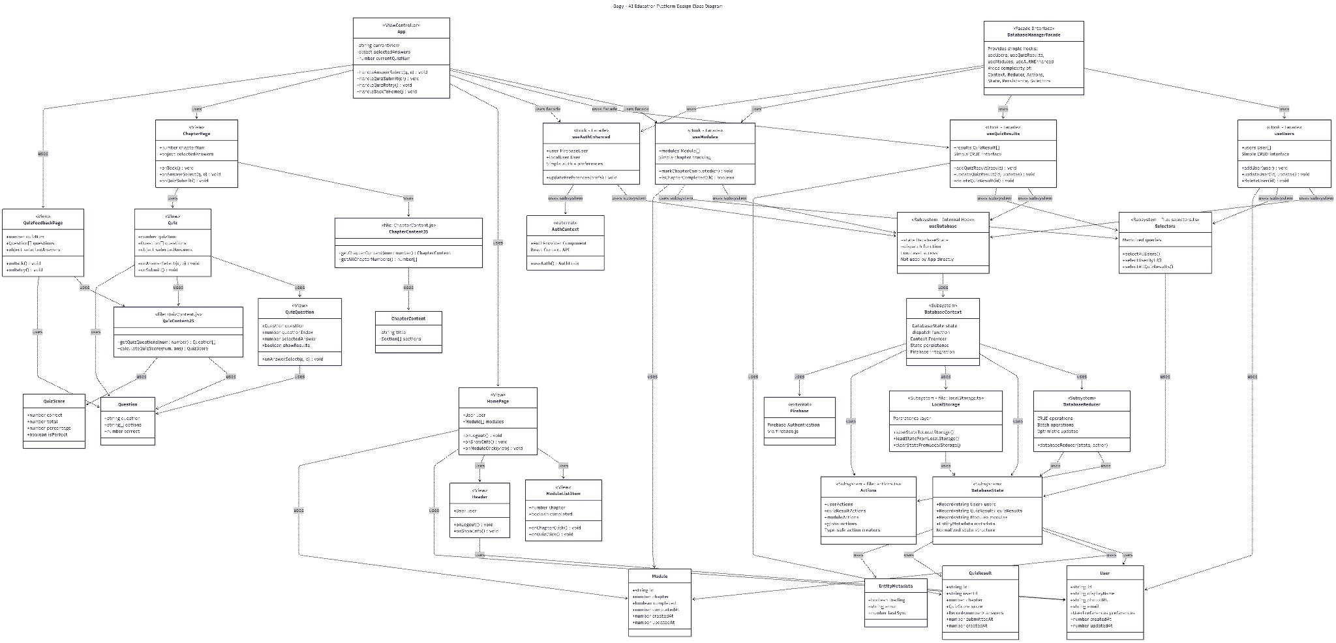

Narrative - Architecture Overview

Application Structure
Gogy is a React-based AI education platform implementing a single-page application architecture. The application follows a component-based design pattern with clear separation between view components, controller logic, helper functions, and domain objects. The main controller (App) manages application state and orchestrates navigation between different views based on user interactions.

Component Architecture
The application consists of several key view components that render different parts of the user interface:

- Header: Displays user profile information and navigation controls
- HomePage: Main landing page showing available learning modules
- ModuleListItem: Individual module representation with chapter link and quiz access
- ChapterPage: Displays educational content for a specific chapter with embedded quiz
- Quiz: Interactive quiz interface for knowledge assessment
- QuizQuestion: Individual question component with multiple choice options
- QuizFeedbackPage: Results page showing score and detailed answer review

State Management
The App component serves as the main view controller, maintaining critical application state including the current view (home, chapter, quiz, or feedback), completed modules tracking, selected quiz answers, and the current quiz number. This centralized state management ensures consistent data flow throughout the application and enables features like progress tracking and answer persistence.

Authentication System
User authentication is handled through Firebase Authentication, abstracted behind a custom AuthContext. The useAuth hook provides components with access to the current user object and authentication methods (login/logout). The AuthProvider wraps the entire application, making authentication state available globally through React's Context API.

Content Management
Educational content and quiz data are managed through separate helper function modules. ChapterContent.js provides functions to retrieve chapter content and enumerate available chapters. QuizContent.js manages quiz questions and score calculation logic. This separation allows for easy content updates without modifying component logic.

Design Pattern

Facade Pattern (Database Manager)
Description: The Database Manager implements the Facade pattern by providing a simplified interface to a complex subsystem of state management, persistence, and data operations. The facade consists of four custom React hooks (useUsers, useQuizResults, useModules, and useAuthEnhanced) that hide the underlying complexity of the database architecture from the application components.

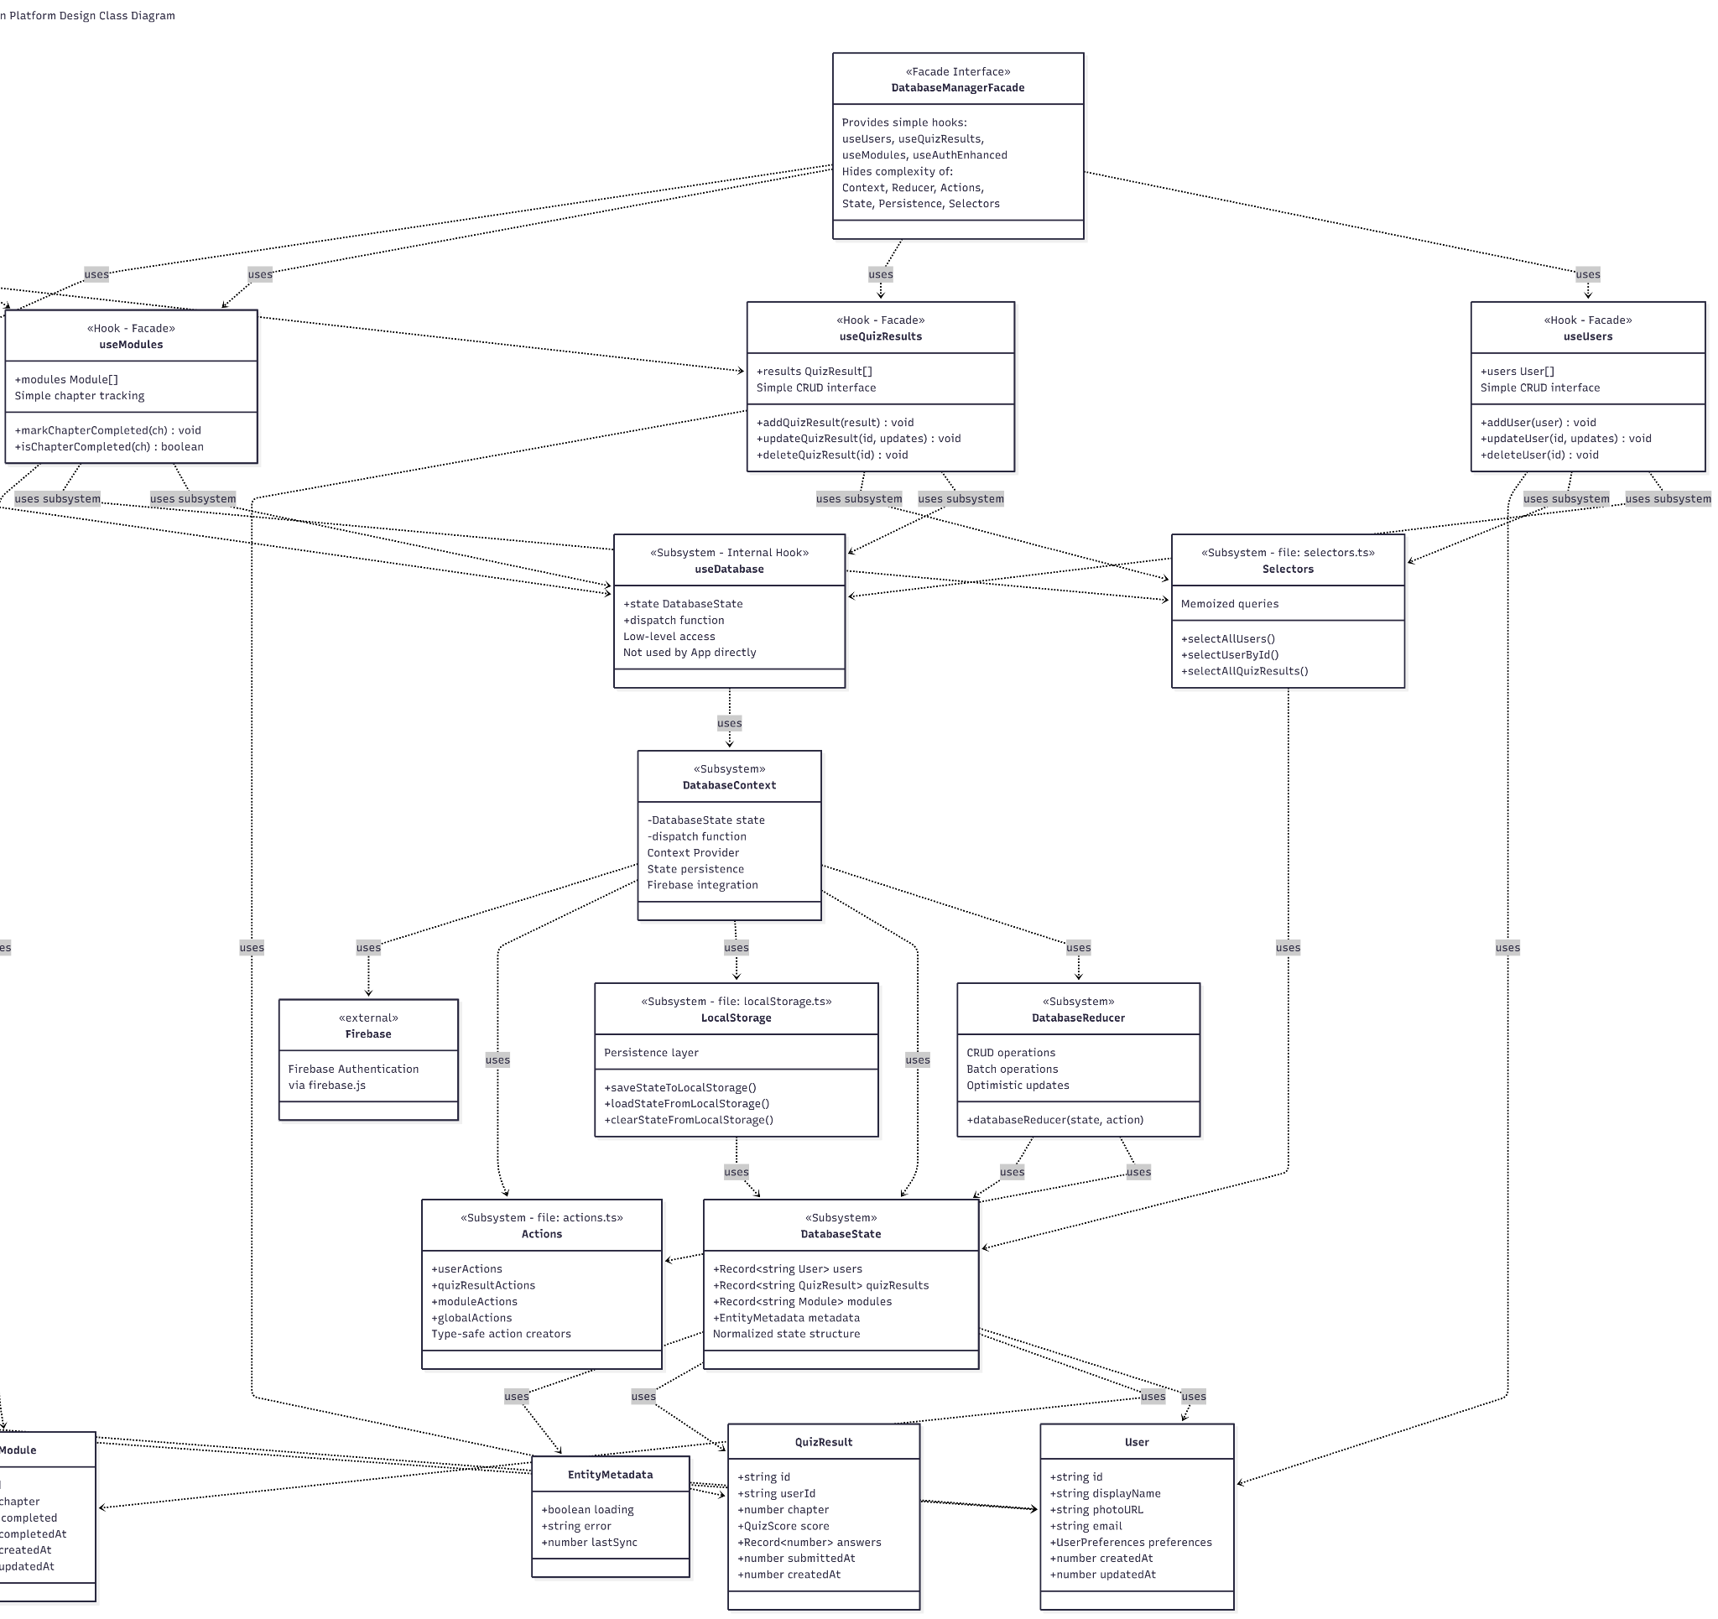

Justification: As Gogy evolved to require persistent local state management with localStorage integration, normalized data structures, CRUD operations, batch updates, and Firebase authentication synchronization, the complexity of state management grew substantially. Without the facade pattern, components like App would need to directly interact with reducers, action creators, selectors, persistence utilities, and context providers—requiring deep knowledge of the internal architecture. The Facade pattern was chosen to:
- Simplify Component Integration: Components can use simple, intuitive methods like markChapterCompleted(chapterNum) or addQuizResult(result) without understanding how data is normalized, persisted to localStorage, or synchronized with Firebase.
- Encapsulate Complexity: The subsystem contains seven interconnected components (DatabaseContext, DatabaseReducer, DatabaseState, Actions, LocalStorage, Selectors, and the internal useDatabase hook). The facade hides this complexity behind four simple hooks.
- Enable Independent Evolution: The internal implementation can be modified (e.g., switching from localStorage to IndexedDB, changing the state structure, or optimizing selectors) without affecting any component that uses the facade hooks.
- Maintain Consistent Interface: All CRUD operations follow the same pattern across different entities (users, quiz results, modules), providing a consistent developer experience.
Example Implementation: When App needs to mark a chapter as completed after a user achieves a perfect quiz score, it simply calls:
const { markChapterCompleted, isChapterCompleted } = useModules();
// Later in the code:
if (score.isPerfect && !isChapterCompleted(chapterNum)) { markChapterCompleted(chapterNum);
}
Behind this simple interface, the facade coordinates multiple complex operations:
- The useModules hook calls the internal useDatabase hook to access state and dispatch
- It checks if the module exists in state.modules[moduleId]
- If not, it creates a new Module object with all required fields (id, chapter, completed, timestamps)
- It dispatches an action through moduleActions.add() or moduleActions.update()
- DatabaseReducer processes the action and updates the normalized DatabaseState
- The state change triggers localStorage persistence via saveStateToLocalStorage()
- Memoized Selectors efficiently query the updated state
- All dependent components automatically re-render with the new data
The component remains completely unaware of this subsystem complexity.
.

External Dependencies

React (18.x)
Purpose: Core UI framework for building component-based user interface

Usage: All components use React functional components with hooks (useState, useContext)

Firebase (9.x)
Purpose: Authentication service for user login/logout functionality

Usage: Integrated through firebase.js configuration file, used by AuthContext

Facade: AuthContext.js provides a facade with useAuth hook and AuthProvider

React Router (Potential - 6.x)
Purpose: Client-side routing (if implemented beyond state-based navigation)

Usage: Currently using state-based view switching, but could be enhanced with React Router

Domain Objects and Types

User
Description: Represents an authenticated user in the system

Attribute | Type | Description
displayName | string | User's full name
photoURL | string | URL to user profile image
email | string | User email address
preferences | UserPreferences | User’s local preferences (theme, notifications, etc.)
createdAt | number | Timestamp when user was created
updatedAt | number | Timestamp of last update

Module
Description: Represents a learning module with completion status

Attribute | Type | Description
id | string | Module identifier (e.g., “module-1”)
chapter | number | Chapter number identifier
completed | boolean | Whether user achieved perfect score
completedAt | number | Timestamp of completion (optional)
lastAccessedAt | number | Timestamp of last access (optional)
createdAt | number | Timestamp of when module was created
updatedAt | number | Timestamp of last update

Question
Description: Quiz question with multiple choice options

Attribute | Type | Description
question | string | Question text
options | string[] | Array of answer choices
correct | number | Index of correct answer

ChapterContent
Description: Educational content for a chapter

Attribute | Type | Description
title | string | Chapter title
sections | Section[] | Array of content sections

QuizScore
Description: Results of quiz assessment

Attribute | Type | Description
correct | number | Number of correct answers
total | number | Total number of questions
percentage | number | Score as percentage
isPerfect | boolean | Whether score is 100%

QuizResult
Description: Stores a user's quiz submission and results

Attribute | Type | Description
id | string | Unique result identifier
userId | string | ID of user who took quiz
chapter | number | Chapter number for the quiz
score | QuizScore | Score details (correct, total, percentage, isPerfect)
answers | Record<number, number> | Map of question index to selected answer index
submittedAt | number | Timestamp when quiz was submitted
createdAt | number | Timestamp when result was created

EntityMetadata
Description: Tracks loading and error state for entity types

Attribute | Type | Description
loading | boolean | Whether data is currently loading
error | string | null | Error message if operation failed
lastSync | number | Timestamp of last synchronization

DatabaseState
Description: Normalized application state structure
Attribute | Type | Description
users | Record<string, User> | Users indexed by ID
quizResults | Record<string, QuizResult> | Quiz results indexed by ID
modules | Record<string, Module> | Modules indexed by ID
metadata | object | Metadata for each entity type
initialized | boolean | Whether state has been hydrated from localStorage
lastSync | number | Timestamp of last state persistence
version | string | State schema version for migrations

Correspondence to Domain Model
The Design Class Diagram builds upon and extends the domain model concepts:

Domain Model Entities Evolved in Design
User (Domain Model) → User (Design)
- Domain model specified: email, username, password
- Design implementation uses Firebase Authentication which provides: displayName, photoURL, email
- Evolution: Authentication is handled by Firebase rather than custom implementation, so password is not stored in the User object. The username concept is replaced by displayName for better user experience. Added photoURL for profile image support.
Content (Domain Model) → ChapterContent (Design)
- Domain model specified: chapterName, getQuizzes()
- Design implementation: title, sections: Section[]
- Evolution: Renamed chapterName to title for clarity. The getQuizzes() method is now handled by the separate QuizContent.js helper module with getQuizQuestions() function, separating content retrieval from content structure.
Quiz (Domain Model) → Quiz Component + QuizContent.js (Design)
- Domain model specified: quizID, quizName, getQuizzes(), getQuestionContents(), getFeedback()
- Design implementation splits into:
  - Quiz View Component: Handles UI rendering with props for quizNum, questions, selectedAnswers, callbacks
  - QuizContent.js: Contains getQuizQuestions() and calculateQuizScore() functions
- Evolution: Quiz identity is simplified to use chapter numbers rather than separate IDs and names. Methods are converted to standalone functions in helper modules. Feedback is handled by a dedicated QuizFeedbackPage component rather than a Quiz method.
QuestionsContent (Domain Model) → Question (Design)
- Domain model specified: questionID, correctAnswer, solutionExplanation, selectAnswer(), getQuestionContents()
- Design implementation: question: string, options: string[], correct: number
- Evolution: Simplified from methods to pure data structure. questionID is replaced by array index. solutionExplanation feature not yet implemented in current design. selectAnswer() method moved to App's handleAnswerSelect() controller method. getQuestionContents() replaced by getQuizQuestions() in QuizContent.js.
Answer (Domain Model) → selectedAnswers object (Design)
- Domain model specified: userID, questionID, selectedAnswer
- Design implementation: Object mapping questionIndex to optionIndex, stored in App state
- Evolution: Simplified to in-memory state objects rather than persistent entities. User association is implicit (current logged-in user). Question identification uses array indices rather than IDs.
Visuals (Domain Model) → Not Directly Implemented
- Domain model specified: visualType, url, loadDiagrams()
- Design status: This entity is not currently implemented in the design
- Future consideration: Could be added to ChapterContent as a visuals: Visual[] array if multimedia content is needed

New Design Elements Not in Domain Model
- Module: New type for tracking chapter completion status (chapter, completed, completedAt, lastAccessedAt, createdAt, updatedAt)
- QuizScore: New type for structured quiz results (correct, total, percentage, isPerfect)
- View Components: All React UI components (Header, HomePage, ModuleListItem, ChapterPage, etc.) are presentation layer additions
- App Controller: Main state management and navigation controller not represented in domain model
- AuthContext: Authentication abstraction layer using React Context API
- Helper Function Modules: ChapterContent.js and QuizContent.js provide separation of business logic
- Database Manager: Complete state management subsystem implementing the Facade pattern.
- Typescript Integration: Type definitions for all entities, state, and actions to ensure type safety throughout the database manager

